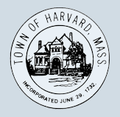
Transfer Station Committee
AGENDA
Tuesday, March 13, 2018
12:30 p.m.
Town Hall
Tom Philippou, chair, Irene Congdon, Tessa David, Tim Kilhart, Libby Levison, Stu Sklar, Ken Swanton,
New business
- Call Meeting to Order
- Public comment
- Review: Board of Selectman appearance and the committee’s charge
- Discussion: Response to new questions and publicizing key information
- Discussion: Irene’s proposed implementation and a potential timeline
- Discussion: Updates from MassToss and MassDEP
- Consider change of meeting times
- Approve minutes
- Proposed agenda items for next meeting

Old business

- Discussion: implementation of SMART
- Discussion: Proposals and options available to be considered for Harvard’s implementation of SMART
- Discussion: Options for vending stickers and bags
- Review past financials

