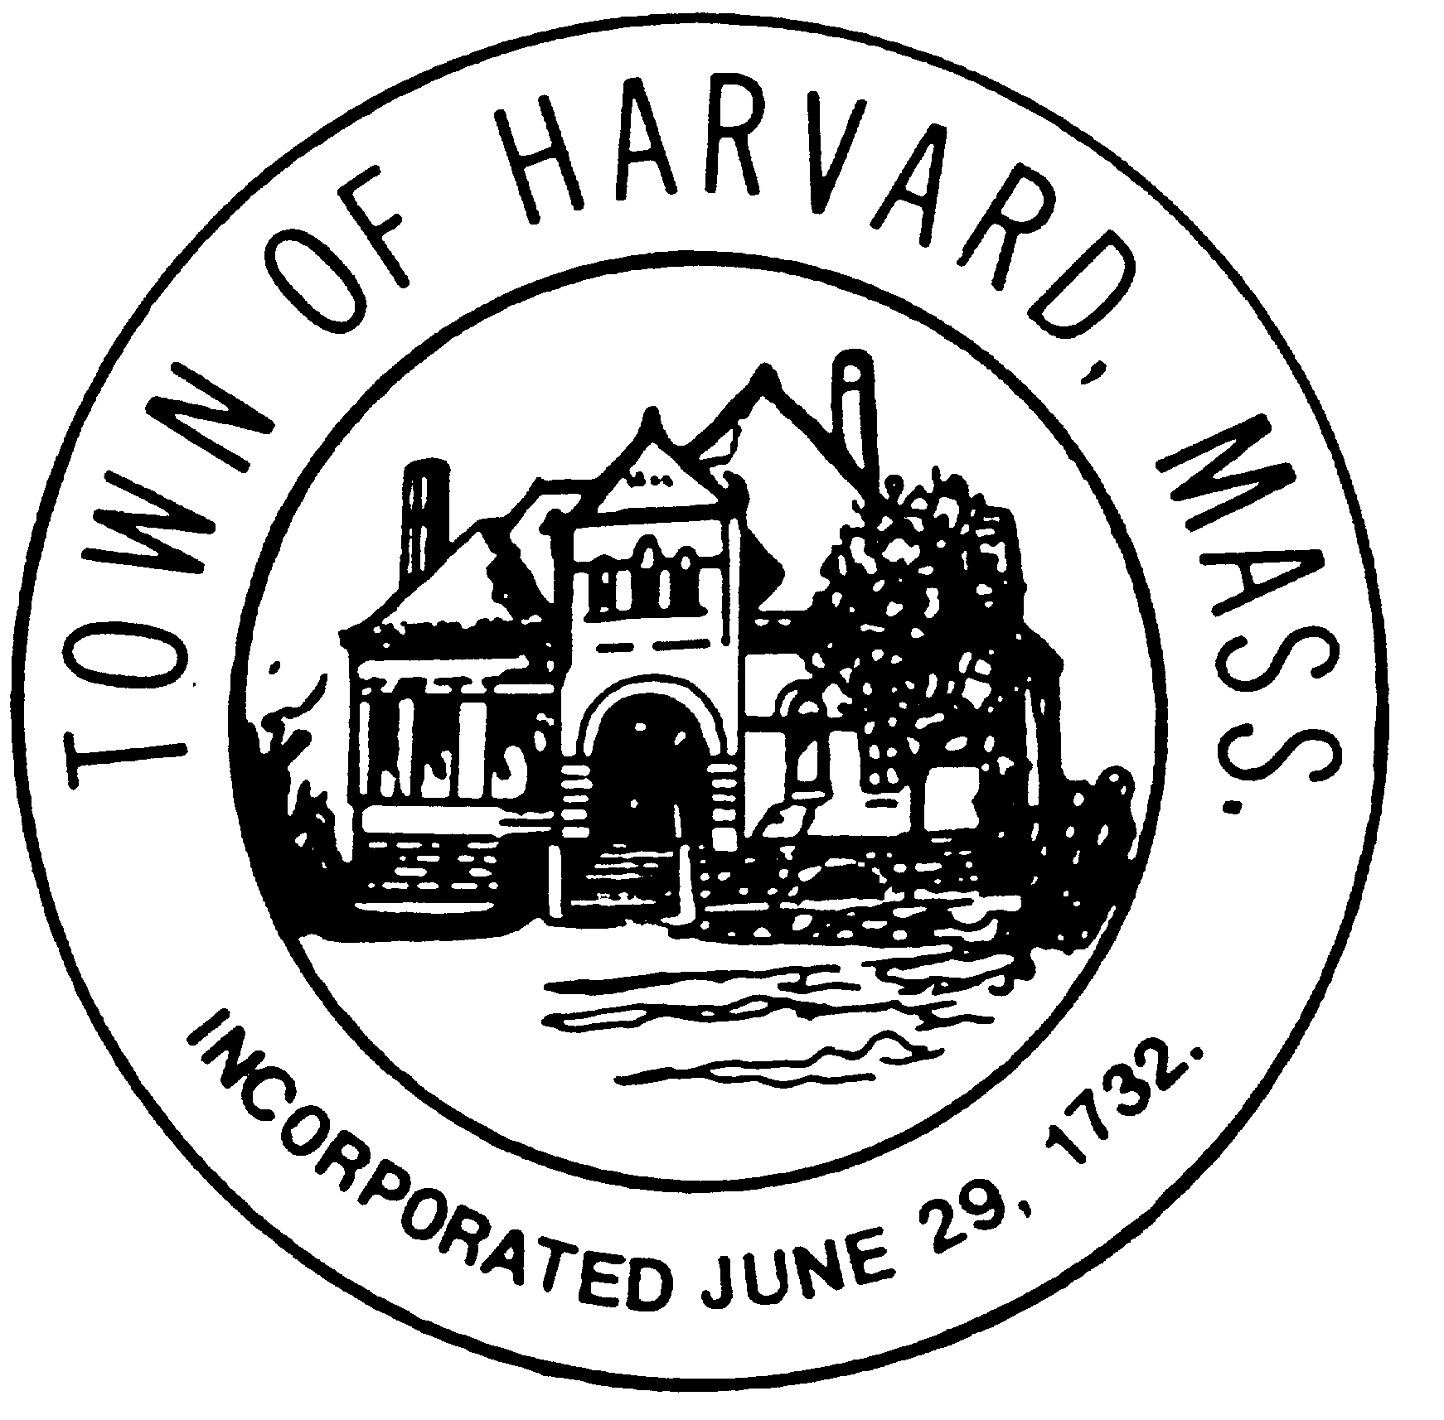

OFFICE OF THE
PLANNING BOARD
13 AYER ROAD HARVARD, MA 01451 978-456-4100 www.harvard.ma.us

To: Marlene Kenney, Town Clerk
Harvard Town Hall
13 Ayer Road
Harvard, MA 01451

SEPTEMBER 13, 2021

HARVARD PLANNING BOARD

NOTICE OF DECISION ON APPLICATION OF

Laura Clarage (“APPLICANT”)

FOR SCENIC ROAD CONSENT

129 POOR FARM ROAD

ASSESSORS MAP 8 PARCEL 35
HARVARD, MA 01451

The Applicant applied to the Harvard Planning Board for consent to alter a scenic road pursuant to Chapter 90 of the Code of the Town of Harvard and MGL Chapter 40, §15C, Scenic Road Designation.

PLANS AND DOCUMENTS SUBMITTED IN SUPPORT OF THE APPLICATION

- Application:

a. An Application for Scenic Road Consent was received by the Harvard Town Clerk on June 29, 2021, with accompanying documents as required, including an Application and Checklist for a Hearing, a certified abutters list, filing fee, and the following:

Supporting narrative providing explanation for the request.

Photographs of the proposed disturbed area.
- Diagram depicting area where wall is proposed to be disturbed and other details.

II. Input from Other Town Boards and/or Interested Parties:

N/A

III. Consultant Reviews:

N/A

IV. Supplemental Materials from Applicant:

None.

OTHER DOCUMENTS AND PUBLIC COMMENT ON THE APPLICATION

- Legal Notices Advertised and Mailed to Abutters:

- The Legal Notice advertising the public hearing to be held on September 13, 2021 on the Scenic Road Consent application appeared in the “The Harvard Press” on ___ and ___, 2021 in compliance with Mass. General Laws.

- An Affidavit of Mailing to Abutters dated June 14, 2021 was endorsed by the Town Clerk on that same date.

The application was presented by the applicant at the public hearing of the Planning Board on September 13, 2021.

FINDINGS

Based on the documents submitted to the Planning Board, the presentation by the Applicant’s representatives at the public hearing, and the report of the Tree Warden, the Planning Board makes the following findings with respect to the Application:

- The applicant is seeking to establish a second driveway entrance at the location shown on the submitted diagram and depicted in the series of photographs submitted with the application. The applicant asserts through the narrative that the driveway is necessary because the existing driveway is not sufficient for access due to proximity to Ayer Road intersection and is a high-volume traffic area and dangerous to back out of the driveway. Further justification and rationale is provided in the narrative.
- In regard to the disturbance proposed to the fieldstone wall located along the right-of-way, the narrative states that approximately 20’ of wall will be removed and that the wall in this area is barely visible due to the stones being mostly buried. The stones to be removed are proposed to supplement the wall in low points..

CONDITIONS AND LIMITATIONS ON EXERCISE OF SCENIC ROAD CONSENT

None

ACTION OF THE PLANNING BOARD – DECISION

Therefore, on September 13, 2021, a motion was made by Stacia Donahue seconded by Brian Cook, and by 5-0 vote of all five attending members of the Planning Board eligible to vote, the request for a Scenic Road Consent is APPROVED with the following condition:

- A site visit shall be conducted with Mr. Ryan to confirm the proper location for these stones.
Appeals may be made pursuant to Massachusetts General Law Chapter 249 §4 and shall be filed within sixty (60) days after the date this decision is filed with the Town Clerk.

ELECTRONIC SIGNATURE

The Harvard Planning Board, on May 18, 2020, voted to authorize the Director of Community and Economic Development, to electronically sign Harvard Planning Board documents during the Covid-19 State of Emergency as per the provisions of M.G.L. Chapter 110G, which the Planning Board recognizes and accepts heretofore throughout the duration of the emergency.

Recorded at the Worcester South District Registry of Deeds as an Electronically Recorded Document Book 62538, Page 390:

___________________________________________
Christopher J, Ryan, AICP, Director of Community and
Economic Development

This decision must be recorded at the Worcester District Registry of Deeds, Worcester, Massachusetts before it becomes valid.

This is to certify that as of __________________________ no notice of appeal has been filed with this office in regard to this decision.

Signed: ________________________________
Marlene Kenney, Town Clerk

