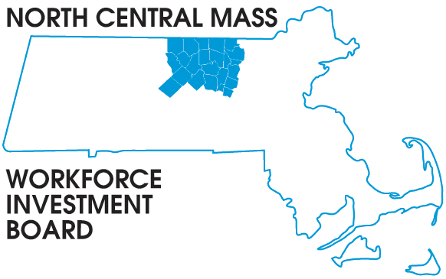
100 Erdman Way Leominster, MA 01453 Phone: (978) 534 1023 Fax: (978) 534 1807

BOARD OF DIRECTORS MEETING

Tuesday, December 12, 2017

North Central Chamber of Commerce
860 South Street, Fitchburg, MA
8:00 a.m. – 9:30 a.m.

AGENDA

Approve Minutes of the September 12, 2017 meeting (Vote required)

Executive Committee Report
Finance: Mike Noble, Audit, new fiscal review processes, etc.

Executive: Barbara Mahoney, Workforce Summit, grant updates etc.

Approve the Executive Committee report November 28, 2017 (Vote required)

Discuss extending the current Career Center structure (Vote required)

Presentation:
Regional Planning data and final report to the Secretaries
Tim and Rachael

Career Center Update: Beth
Directors Report: Tim

Other Business

