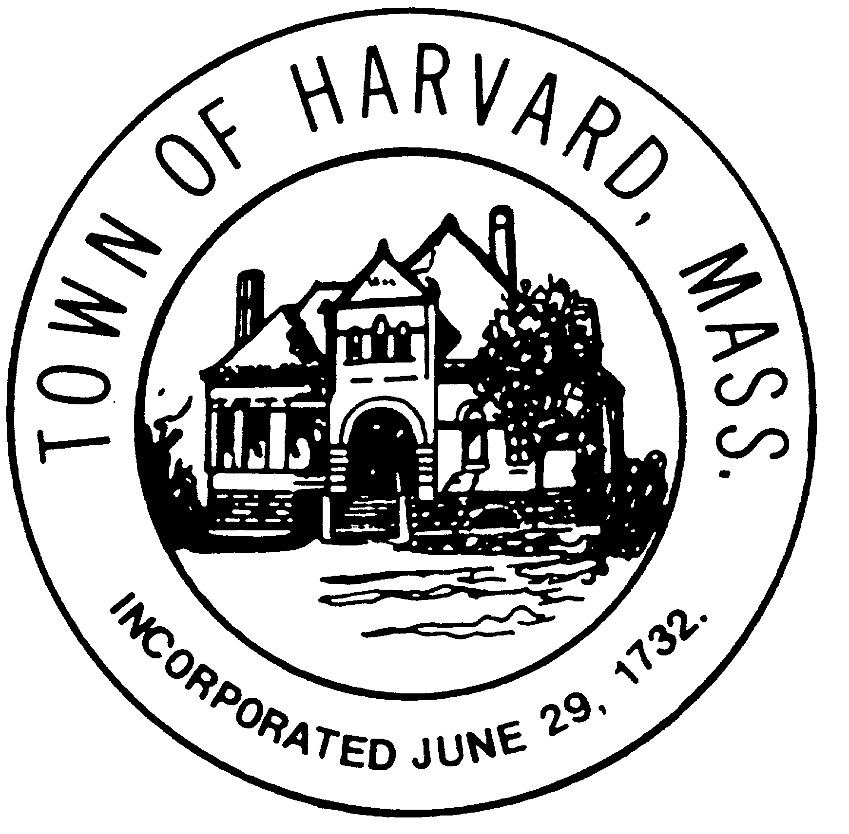

OFFICES OF THE
BOARD OF SELECTMEN
TOWN ADMINISTRATOR
13 AYER ROAD HARVARD, MA 01451 www.harvard.ma.us
978-456-4100 EXT. 312 (978) 456-4107 (fax)

COMPLETE STREETS POLICY
HARVARD, MASSACHUSETTS
Vision and Purpose
The purpose of this policy is to enable the Town of Harvard to provide safe, convenient and accessible routes for all users of local roadways, trails, and transit systems, including pedestrians, bicyclists, transit riders, motorists, buses, and emergency vehicles. “All Users” includes people of all ages and abilities. Complete Streets principles contribute to the safety, health, economic viability, and quality of life in a community by providing accessible and efficient connections between home, school, work, recreation and retail destinations, and by improving the pedestrian and vehicular environments.
This Policy seeks to encourage the safe use of all modes of transportation, to enable convenient travel as part of daily activities, to improve public health by providing walking and bicycle alternatives to vehicle travel, and to meet the needs of all users of streets, for people of all ages, abilities and income levels. This Complete Streets Policy will focus on establishing a connected and integrated network to serve all users of Harvard’s roads.
Core Commitment
The Town of Harvard recognizes that users of various modes of transportation, including but not limited to, pedestrians, cyclists, transit and school bus riders, motorists, users of wheelchairs or other power-driven mobility devices, delivery and service personnel, emergency responders, and freight haulers are legitimate users of streets and deserve safe facilities.
The Town also recognizes that all road projects and adjacent site development, whether developing new roads or maintaining or reconstructing existing roads, are opportunities to apply Complete Streets design principles. The Town will, to the maximum extent practical, plan, design, construct, maintain, and operate designated priority streets to provide for a comprehensive and integrated network of facilities for all users.
All transportation infrastructure in the Town of Harvard, including upgrades or expansions of roads in the public right-of-way, shall comply with this Complete Streets Policy to the maximum extent practical. Private developments shall also comply with Complete Streets principles. In addition, to the extent practical, state-owned roadways will comply with Complete Streets principles.
Transportation infrastructure may be excluded from this policy, upon approval by the Selectmen, where documentation and data indicate that:
- Specific users are prohibited by law, such as limited access highways. In these cases, an effort will be made to provide alternative accommodations.
- Where construction would create significant adverse impacts to streams, wetlands, flood plains, or scenic and historic resources.
- Where Complete Streets measures would constitute a threat to public safety.
- Cost are excessively disproportionate to the benefit.
- Where the public right-of-way or adjacent land is constrained in a manner that inhibits the addition of transit, bicycle, or pedestrian improvements and no other cost effective alternatives are available.
Best Practices
Harvard has a beautiful and historic Town Center and many of its rural roads are designated as Scenic Roads under G.L. c. 40, §15C. Accordingly, all proposed projects and improvements will be evaluated in the context of Harvard’s community character and quality of the neighborhood. Complete Streets principles include the development and implementation of projects in a manner that is sensitive to the community’s physical, economic, and cultural setting. The context-sensitive approach to process and design shall consider the needs and values of both stakeholders and the community and encourage participation of those affected in order to gain project consensus. The overall goal is to preserve and enhance scenic, aesthetic, historical, and environmental resources while improving and maintaining safety, mobility, and infrastructure conditions.
Complete Streets principles may be achieved by incorporating elements into a project at the start or by adding elements incrementally through a series of smaller improvements or maintenance activities over time. The latest edition of design guidance documents will be used in the implementation of Complete Streets, including:
- The Massachusetts Department of Transportation’s Project Design and Development Guidebook
- The American Association of State Highway Transportation Officials’ (AASHTO) A Policy on Geometric Design of Highway and Streets
- The United States Department of Transportation’s Federal Highway Administration’s Manual on Uniform Traffic Control Devices (MUTCD)
- The Architectural Access Board’s (AAB) 521CMR Rules and Regulations
- Documents and plans created for the Town of Harvard, such as the Master Plan, Open Space and Recreation Plan, Town Center Action Plan, Harvard Town Center Transportation Study, Freedom’s Way Landscape Inventory, and Commercial Design Guidelines.
Implementation
The Town shall make Complete Streets practices a routine part of everyday operations, shall approach transportation projects as an opportunity to improve streets and the transportation network for all users, and shall work in cooperation with other departments, state and federal agencies, and adjoining towns to implement Complete Streets.
- The Department of Public Works will maintain a comprehensive inventory of pedestrian and bicycle facilities and any other relevant infrastructure on each street. The Town will prioritize projects to eliminate gaps in sidewalks, remove barriers to people with disabilities, and enhance pedestrian and bicycle safety.
- The Director of Public Works will conduct a Complete Streets review of all transportation infrastructure projects during conceptual design.
- The Town shall make all efforts to provide training for staff on Complete Streets principles and best practices through workshops and other means.
- The Town will promote inter-departmental coordination among all Town departments to achieve the most responsible and efficient use of resources for activities within public rights-of-way.
- The Town will seek appropriate sources of funding, including grants, for implementing its Complete Streets policy.
- The Planning Board will evaluate annually Complete Streets implementation for effectiveness, identify opportunities for improvement, and present the results of the evaluation to the Selectmen. The evaluation shall include performance measures such as linear feet of new or improved sidewalks, miles of bicycle accommodations, new or improved crosswalks, curb ramp improvements, and review of new traffic counts and vehicle crash data to help set priorities for local action.

