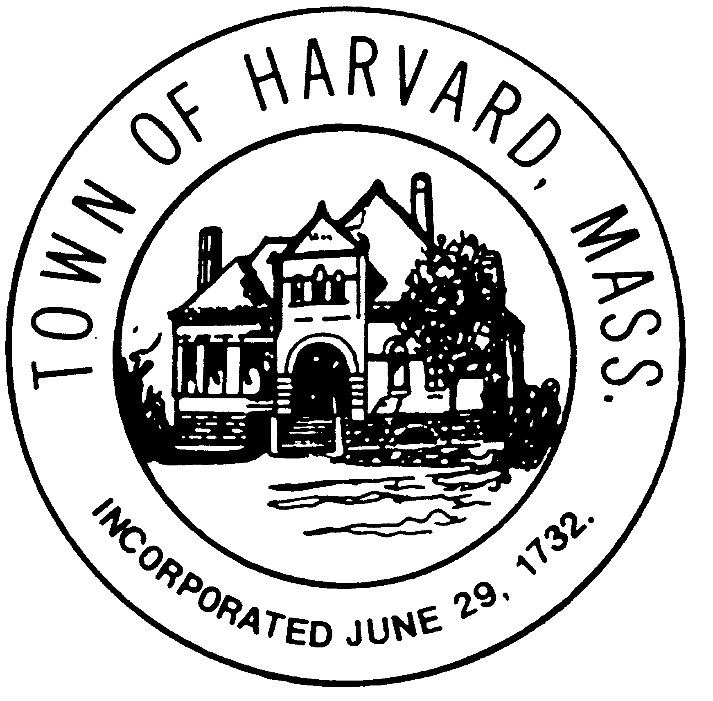
Office of The
Board of Health
13 Ayer Road, Harvard, MA 01451
978-456-4100, ext. 428
boh@harvard-ma.gov

2024 STABLE PERMIT APPLICATION

Date:
Stable Address:
Applicant Name:
Mailing Address:
Telephone:
E-mail Address:

STABLE USE (Circle all that apply)
PRIVATE | BOARDING
TRAINING | LESSONS
OTHER (fill in):

NUMBER OF ANIMALS ON PROPERTY
HORSES |  | PONIES |  | DONKEYS
CATTLE |  | GOATS |  | SHEEP
ALPACA |  | LLAMA |  | SWINE
POULTRY |  | OTHER (fill in):

Are there known wetlands resource area (including ponds & streams) within 100 feet of this property? (Please circle one.)

Yes No I don’t know

Applicant Name Stable Address

LAYOUT PLAN
Please sketch a drawing of barn/stable and pasture with dimensions from house, property line, well and any possible wetlands. If you are able to print a property map with Wetland overlays using the GIS mapping program linked on the Assessor’s webpage, it would be helpful to draw your sketch on the same and attach it to this application.

MANURE MANAGEMENT
Describe in detail how you plan to manage and dispose of the manure (e.g. location of the manure pile, method of disposal or transport and pest control).

ADDITIONAL NOTES:

Office Use Only: Approval

Date of Issuance Permit #

